AI Enabled CAD Tool

# Idea

I am interested in using an AI enabled CAD tool to develop electronic hardware faster and better than currently possible. I wonder if the miniPCB project could be come a dataset for rapidly training small AI-enabled CAD programs.

# Process

1. Imagine the future of work.
2. Learn about the system design.
3. Identify an actionable plan.
4. … pause for effect …

# System Diagram

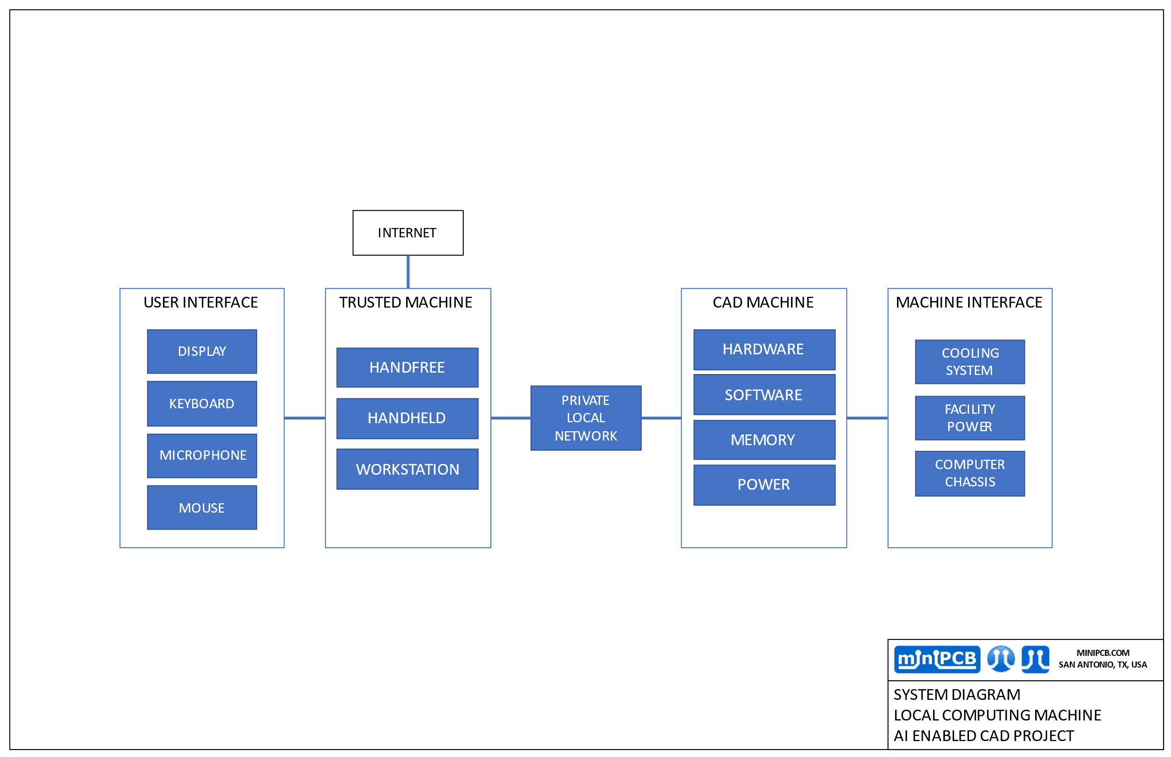

# General Specifications

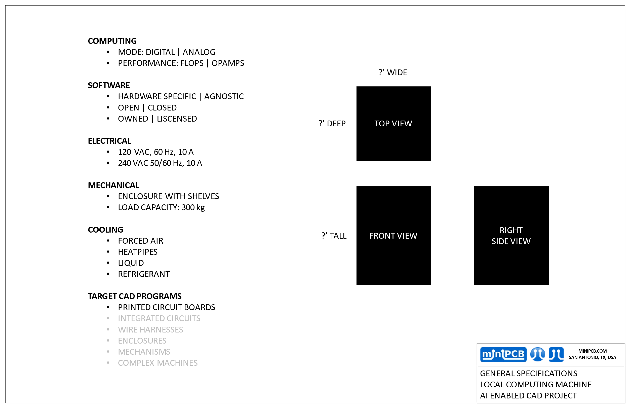

## Imagine

### Imagination Seeds

* What will the AI CAD tool be doing?
* How will I want to be interacting with the AI CAD tool?
* What are the best AI CAD tools currently available?
* What might the future’s best AI CAD tools look like?
* What hardware is best for running an AI CAD tool?
* What will future hardware look like for AI CAD tool systems?
* What fears and hopes will be in the mind of the manager considering purchasing an AI CAD tool?

### Server

* Select hardware
* Select operating system
* Install computer chassis
* Configure the server
* Implement security

### Client

* Desktop PC
* EAGLE

# Change and Liability Notice

This document is subject to change without notice. While effort has been made to ensure the accuracy of the material contained within this document, Nolan Manteufel shall under no circumstances be liable for incidental or consequential damages or related expenses resulting from the use of this document.

# Trademark Notice

miniPCB is a trademark of Nolan Manteufel.

This specification does not constitute permission to use the miniPCB trademark.

|  |  |  |
| --- | --- | --- |
| WORDMARK | FIGUREMARK | FIGUREMARK |
| miniPCB™ | A picture containing drawing  Description automatically generated™ | Icon  Description automatically generated™ |

# Revision History

|  |  |  |  |
| --- | --- | --- | --- |
| REV | DESCRIPTION | ECO | DATE |
| A | Initial Release | N/A | 05MAR2023 |
| B | Added system diagram and general specifications | N/A |  |